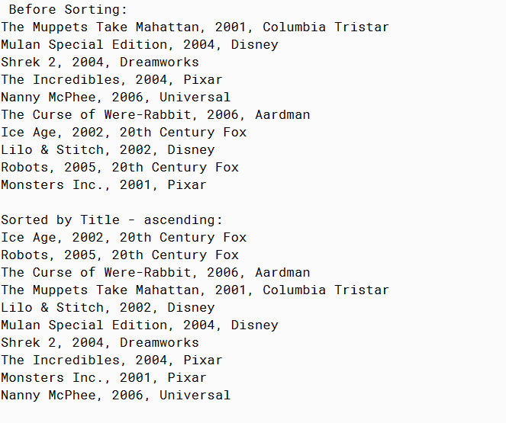

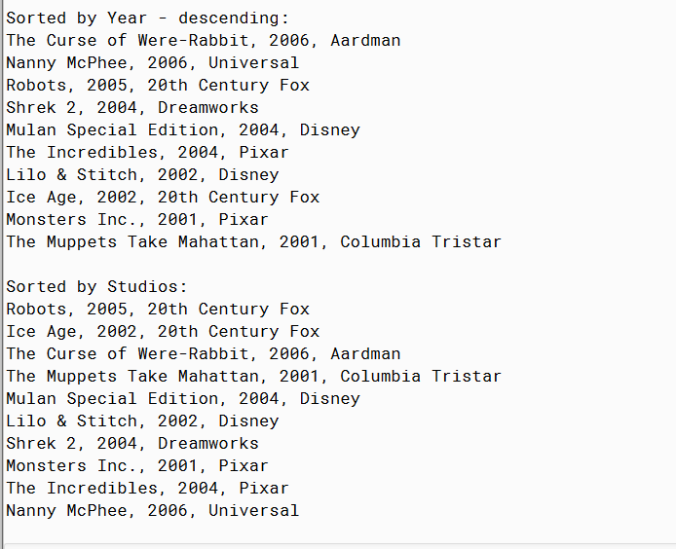

PMR: This assignment was really easy since it was basically just adding onto the previous assignment. I didn’t have to really change anything and I just added a few things to make the program look nicer and run efficiently. I enjoyed this assignment.

/\*\*

\* Movie Interface

\*

\* @author Anika Jallipalli

\* @version 4/11/2020

\*/

public class Movie3

{

private String title;

private int year;

private String studio;

public Movie3(String title, int year, String studio)

{

this.title = title;

this.year = year;

this.studio = studio;

}

public String toString()

{

String string = title + ", " + year + ", " + studio;

return string;

}

public String getTitle()

{

return title;

}

public int getYear()

{

return year;

}

public String getStudio()

{

return studio;

}

public void setStudio(String a)

{

studio = a;

}

}

/\*\*

\* run the program

\*

\* @author Anika Jallipalli

\* @version 4/11/2020

\*/

import java.lang.\*;

public class TestMovie3

{

public static void main(String[] args)

{

Movie3 muppets = new Movie3("The Muppets Take Mahattan",2001,"Columbia Tristar");

Movie3 mulan = new Movie3("Mulan Special Edition",2004,"Disney");

Movie3 shrek = new Movie3("Shrek 2",2004,"Dreamworks");

Movie3 incredibles = new Movie3("The Incredibles",2004,"Pixar");

Movie3 nanny = new Movie3("Nanny McPhee",2006,"Universal");

Movie3 rabbit = new Movie3("The Curse of Were-Rabbit", 2006,"Aardman");

Movie3 iceage = new Movie3("Ice Age",2002,"20th Century Fox");

Movie3 lilo = new Movie3("Lilo & Stitch",2002,"Disney");

Movie3 robots = new Movie3("Robots",2005,"20th Century Fox");

Movie3 monsters = new Movie3("Monsters Inc.",2001,"Pixar");

Movie3[] movies = new Movie3[] {muppets, mulan, shrek, incredibles, nanny, rabbit,

iceage, lilo, robots, monsters};

Movie3[] newmovies = new Movie3[movies.length];

System.out.println("Before Sorting:");

printMovies(movies);

System.out.println();

System.out.println("Sorted by Title - ascending:");

sortTitles(movies,1);

printMovies(movies);

System.out.println();

System.out.println("Sorted by Year - descending:");

sortYears(movies,2);

printMovies(movies);

System.out.println();

System.out.println("Sorted by Studios:");

sortStudios(movies,1);

printMovies(movies);

}

public static void printMovies(Movie3[] a)

{

for(int i = 0; i < a.length; i++)

{

System.out.println(a[i].toString());

}

}

public static void sortTitles(Movie3[] a, int b)

{

if(b==1)

{

for (int i = 0; i < a.length - 1; ++i)

{

int minIndex = i;

for (int j = i + 1; j < a.length; ++j)

{

if ((a[j].getStudio()).compareTo(a[minIndex].getStudio()) < 0)

{

minIndex = j;

}

}

Movie3 temp = a[i];

a[i] = a[minIndex];

a[minIndex] = temp;

}

}

else if (b==2)

{

for (int i = 0; i < a.length - 1; ++i)

{

int minIndex = i;

for (int j = i + 1; j < a.length; ++j)

{

if ((a[j].getStudio()).compareTo(a[minIndex].getStudio()) > 0)

{

minIndex = j;

}

}

Movie3 temp = a[i];

a[i] = a[minIndex];

a[minIndex] = temp;

}

}

else

{

System.out.println("ERROR");

}

}

public static void sortYears(Movie3[] a, int b)

{

Movie3 temp;

int i;

int k;

int posmax;

if(b==1)

{

for ( i = a.length - 1 ; i > 0 ; i-- )

{

posmax = 0;

for ( k = 1 ; k <= i ; k++ )

{

if ( a[ k ].getYear() > a[ posmax ].getYear() )

{

posmax = k;

}

}

temp = a[ i ];

a[ i ] = a[posmax ];

a[ posmax ] = temp;

}

}

else if (b==2)

{

for ( i = a.length - 1 ; i > 0 ; i-- )

{

posmax = 0;

for ( k = 1 ; k <= i ; k++ )

{

if ( a[ k ].getYear() < a[ posmax ].getYear() )

{

posmax = k;

}

}

temp = a[ i ];

a[ i ] = a[posmax ];

a[ posmax ] = temp;

}

}

else

{

System.out.println("ERROR");

}

}

public static void sortStudios(Movie3[] a, int b)

{

if(b==1)

{

for (int i = 0; i < a.length - 1; ++i)

{

int minIndex = i;

for (int j = i + 1; j < a.length; ++j)

{

if ((a[j].getStudio()).compareTo(a[minIndex].getStudio()) < 0)

{

minIndex = j;

}

}

Movie3 temp = a[i];

a[i] = a[minIndex];

a[minIndex] = temp;

}

}

else if (b==2)

{

for (int i = 0; i < a.length - 1; ++i)

{

int minIndex = i;

for (int j = i + 1; j < a.length; ++j)

{

if ((a[j].getStudio()).compareTo(a[minIndex].getStudio()) > 0)

{

minIndex = j;

}

}

Movie3 temp = a[i];

a[i] = a[minIndex];

a[minIndex] = temp;

}

}

else

{

System.out.println("ERROR");

}

}

}